Lesson 4: How does the speed (and the mass) of the vehicles in a collision affect the outcome?

Previous Lesson | We used what we figured out from video data and mathematical modeling to identify design features that can decrease stopping distances to prevent collisions in the event of a sudden obstacle. We were left wondering about how speed at the moment of a collision affects the outcome of the collision, assuming it cannot be avoided.
This Lesson  Investigation  2 days   | 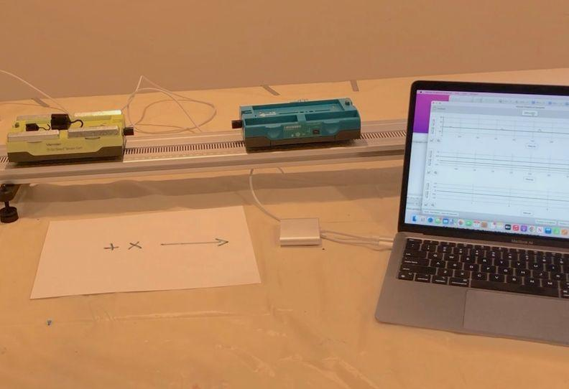 | We analyze videos and graphs of data collected from speed and force sensors for two carts during several collisions. We develop a series of mathematical representations to describe quantitative patterns we notice between the masses and the changes in velocity of the two carts.
Next Lesson | We will collect data from a simulation and use it to argue for whether the relationships we discovered hold for any other collision conditions. We will use alternate algebraic models to solve for the mass or velocity of an object before a collision.

BUILDING TOWARD NGSS  HS-ETS1-3, HS-PS2-2, HS-PS2-3, HS-PS2-1   | What students will do  4.A Analyze data collected from speed and force sensors and use multiple mathematical representations (bivariate graphs, ratios, geometric models, algebraic equations) to identify and describe patterns in the relationship between different variables (force, mass, velocity changes of two objects in a collision. (SEP: 5.2; CCC 1.1, 1.4; DCI:PS2.A.2)  What students will figure out  - The contact forces on each object change in magnitude over the period of time of the collision, but remain equal in magnitude and opposite in direction to each other throughout.  - Both the magnitude of the change in velocity of an object and its mass are positively associated with the magnitude of the contact force it experiences over the time of a collision.  - The total momentum of the objects in a collision is conserved when there are no small external forces on two objects during a collision; momentum conservation provides a close approximation of the outcomes, when the external forces on the objects (e.g. friction) are much smaller in magnitude than the average collision force.

Lesson 4 • Learning Plan Snapshot
Part | Duration | Summary | Slide | Materials
1 | 3 min | NAVIGATE  Consider the effects of slowing down a vehicle or not before a collision. | A
2 | 4 min | ANALYZE DATA  Make initial observations of the collisions A.1, A.2, and A.3 in a video. | B | https://www.youtube.com/watch?v=5F6rEvlSsW0&list=PLSLDxqPb5NQmc9aOPrh0SjG_BRiZsVdWA&index=3, computer, projector
3 | 7 min | CONSTRUCT INITIAL EXPLANATIONS AND MAKE PREDICTIONS  Develop initial explanations for the speed changes in the carts and make predictions about how the forces on the carts would compare in each of these collisions. | C-D | M-E-F triangle poster from the prior unit
4 | 10 min | ANALYZE AND INTERPRET DATA  Orient to a video of the force sensors in the collision cart system, analyze the related data from three collisions, with a partner, and discuss the patterns in this data as a class. As a class,begin developing a poster that connects the forces acting on two colliding objects and the time of collision. | E-F | Collisions A-C Graphs, student notebook, https://www.youtube.com/watch?v=oU7cI4sSMbQ&list=PLSLDxqPb5NQmc9aOPrh0SjG_BRiZsVdWA&index=2, computer, projector, Variable Half Sheets, Relationships between variables for 2 colliding objects poster, tape, marker, extra half sheets of paper
5 | 18 min | ANALYZE AND INTERPRET DATA AS A CLASS  Discuss the patterns in the data as a class. Develop a poster that identifies the variables in the collision and relationships between them. Replace speed with velocity on the graphs after discussing vectors. | G-K | Collisions A-C Graphs, student notebook, Relationships between variables for 2 colliding objects poster, tape, marker, half sheets of paper, Variable Half Sheets
6 | 3 min | COMPLETE AN EXIT TICKET  Independently determine which collision produced the largest changes in velocity for each cart and how much the velocity of both the carts changed in that collision. | L | Collisions A-C Graphs

End of day 1
7 | 2 min | SHARE EXIT TICKET RESPONSES  Discuss which collision produced the largest changes in velocity and the magnitude of that change. | M | Collisions A-C Graphs
8 | 7 min | RECORD ADDITIONAL RELATIONSHIPS AND VARIABLES  As a class, update the Relationships between variables for 2 colliding objects poster by including ΔV and its relationship with the other variables. Discuss reasons for symmetry in forces and velocity changes. | N-O | Relationships between variables for 2 colliding objects poster, Variable Half Sheets, tape, marker, half sheets of paper
9 | 6 min | PREDICT ADDITIONAL COLLISION CONDITIONS  Make predictions related to changes in mass for three additional collision scenarios. | P | Relationships between variables for 2 colliding objects poster, Variable Half Sheets, tape, markers, half sheets of paper.
10 | 10 min | ANALYZE AND INTERPRET DATA  Analyze collision videos and work with a partner to note how changes in mass affect the outcomes of a collision. | Q | Collisions D-F Graphs, https://www.youtube.com/watch?v=DXFVadiFb_c&list=PLSLDxqPb5NQmc9aOPrh0SjG_BRiZsVdWA&index=3, computer
11 | 7 min | ARGUE FROM EVIDENCE  Identify the relationship between mass in the system, magnitude of the forces acting on the objects during a collision and the resulting changes in velocity. Update the Relationships between variables for 2 colliding objects poster. | R | Collisions D-F Graphs, calculator, Relationships between variables for 2 colliding objects poster, Variable Half Sheets, tape, markers, half sheets of paper.
12 | 7 min | USE MATHEMATICAL THINKING  Compare ratios of masses to ratios of velocity changes for both objects in a collision. Develop a symbolic representation of this relationship and use it to predict the outcome of different mass ratio collisions. | S-U | Collisions D-F Graphs, calculator, Relationships between variables for 2 colliding objects poster, Variable Half Sheets, tape, markers, half sheets of paper.
13 | 6 min | NAVIGATE  Predict the generalizability of the symbolic relationship to other collision conditions. | V-W

End of day 2

Lesson 4 • Materials List
 | per student | per group | per class
Lesson materials | - science notebook  - Collisions A-C Graphs  - student notebook  - Collisions D-F Graphs  - calculator | - https://www.youtube.com/watch?v=DXFVadiFb_c&list=PLSLDxqPb5NQmc9aOPrh0SjG_BRiZsVdWA&index=3  - computer | - https://www.youtube.com/watch?v=5F6rEvlSsW0&list=PLSLDxqPb5NQmc9aOPrh0SjG_BRiZsVdWA&index=3  - computer  - projector  - M-E-F triangle poster from the prior unit  - https://www.youtube.com/watch?v=oU7cI4sSMbQ&list=PLSLDxqPb5NQmc9aOPrh0SjG_BRiZsVdWA&index=2  - Collisions A-C Graphs  - Variable Half Sheets  - Relationships between variables for 2 colliding objects poster  - tape  - marker  - extra half sheets of paper  - half sheets of paper  - markers  - half sheets of paper.

Materials preparation (15 minutes)

Review teacher guide, slides, and teacher references or keys (if applicable).

Make copies of handouts and ensure sufficient copies of student references, readings, and procedures are available.

Display the M-E-F triangle poster from the prior unit: OpenSciEd Unit P.2: How forces in Earth’s interior determine what will happen to its surface? (Earth’s Interior Unit) in the room to refer to in this lesson.

Prepare a piece of poster paper titled, Relationships between variables for 2 colliding objects poster.

Print Variable Half Sheets. Cut out each rectangle. Add these to the Relationships between variables for 2 colliding objects poster along with the 2 half and 4 full sheets of paper with the corresponding colored text and arrows on them to ensure they all fit on the poster. Remove all of these from the poster. You will attach these to the poster incrementally in this lesson as you co-construct this poster with each class. You will then remove them between classes to reuse, as well as replacing a few of the annotations you add, before eventually leaving them up permanently on the poster at the end of this lesson.

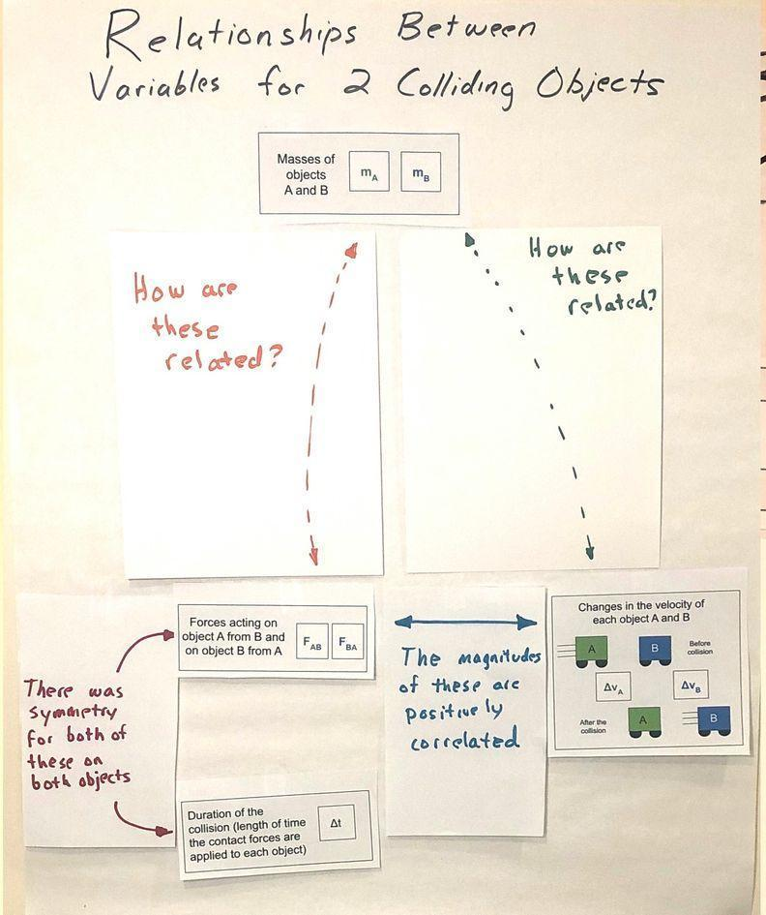 | 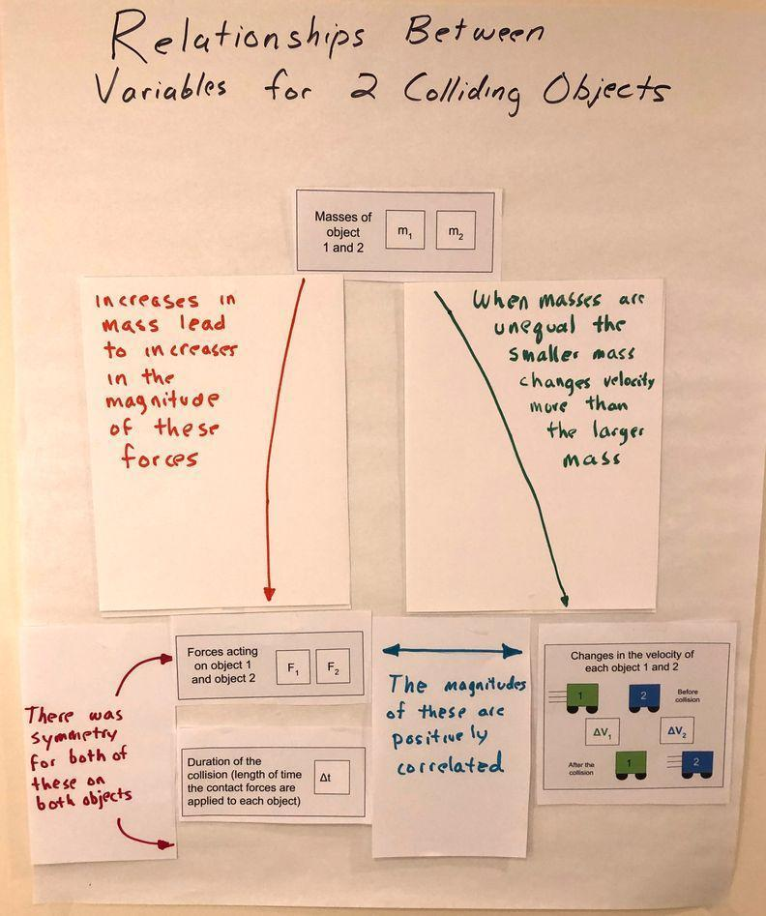 | 

Prepare one piece of poster paper titled, Mathematical relationships in our collisions. To save paper, you will use up each of these only with your last period class, in order to create a permanent artifact for all classes to refer to later. For classes that you have before your last class, you can reuse the whiteboard to record something similar.

Test the videos students will view in this lesson:
- https://www.youtube.com/watch?v=5F6rEvlSsW0&list=PLSLDxqPb5NQmc9aOPrh0SjG_BRiZsVdWA&index=3
- https://www.youtube.com/watch?v=oU7cI4sSMbQ&list=PLSLDxqPb5NQmc9aOPrh0SjG_BRiZsVdWA&index=2
- https://www.youtube.com/watch?v=DXFVadiFb_c&list=PLSLDxqPb5NQmc9aOPrh0SjG_BRiZsVdWA&index=3

Lesson 4 • Where We Are Going and NOT Going

Where We Are Going

This lesson is designed to coherently build ideas related to the following disciplinary core idea:
- PS2.A.2: Forces and Motion. Momentum is defined for a particular frame of reference; it is the mass times the velocity of the object. (HS-PS2-2)

The lesson is purposefully designed so that students are motivated to keep track of the quantity of mass times speed and notice that it is conserved in collisions, before assigning a scientific term. It is only after getting multiple lines of evidence for such a conserved quantity, that it will be named as momentum in the next lesson.

The graphs in Collisions A-C Graphs intentionally have the y-axis labeled as speed. This is so that students can “just in time” cross out and replace the word “speed” with “velocity” to more accurately reflect what is being plotted on those graphs. This is done after they have analyzed the graphs and after you introduce the word velocity toward the end of the first whole class discussion about what is being shown. Don’t introduce the word velocity before this!.

Students analyze bivariate data in multiple graphs in this lesson to describe collision patterns over time. Students have prior experience in working with graphs to identify trends and quantities over time in OpenSciEd Unit P.1: How can we design more reliable systems to meet our communities’ energy needs? (Electricity Unit) as well as in the non-linear exponential models they derived based on the data they collected related to radioactive decay in OpenSciEd Unit P.2: How forces in Earth’s interior determine what will happen to its surface? (Earth’s Interior Unit).

This lesson provides an opportunity to make connections across courses if students have taken the OpenSciEd chemistry course, by discussing how the incrementally derivation of a suspected algebraic relationship is reminiscent of what they did in OpenSciEd Unit C.1: How can we slow the flow of energy on Earth to protect vulnerable coastal communities? (Polar Ice Unit) to derive thermal energy transfer and conservation of energy relationships.They have also used a similar approach for the efficiency of energy transfer systems in OpenSciEd Unit P.1: How can we design more reliable systems to meet our communities’ energy needs? (Electricity Unit) and relative amounts of different matter due to radioactive decay over time in OpenSciEd Unit P.2: How forces in Earth’s interior determine what will happen to its surface? (Earth’s Interior Unit).

The two core CCMS related ideas that are targeted in this this lesson are CCSS.MATH.CONTENT.HS.N-VM.1 and CCSS.MATH.CONTENT.HS.A-SSE.1b, which are described in further detail at the end of the teacher guide. Talk with your math teacher about where students represent and model with vector quantities and where interpret the structure of expressions

Supporting CCMS related ideas students may bring to the discussion, but are not main learning targets related to interpreting the graphs in Collisions A-C Graphs and Collisions A-C Graphs. Here students may draw on their prior work in high school CCMS with ideas about symmetry, scaling and shifting of functions building new functions from existing functions). They also may draw on their prior work in middle school CCMS with describing two fractions as negative reciprocals of each other.

Where We Are NOT Going

Do not introduce the concept of momentum in this lesson. They will co-develop this concept in the next lesson.

While OpenSciEd Unit P.2: How forces in Earth’s interior determine what will happen to its surface? (Earth’s Interior Unit) introduced forces as vector quantities that have direction and magnitude, the direction of those vectors was treated qualitatively. This unit introduces a way to quantify the vectors of force and velocity, but only in one dimension. In the next unit, students will begin to think about two dimensional vectors to understand and explain orbits in OpenSciEd Unit P.4: Meteors, Orbits, and Gravity (Meteors Unit).

If students completed OpenSciEd Unit 8.1: Why do things sometimes get damaged when they hit each other? (Collisions Unit) in prior grades they would have collected first hand evidence that the forces are equal in strength and opposite in direction in any collision. This is one reason why students aren’t collecting that data first hand in this unit. The other is that Newton’s second law is a learning target for middle school. So the subsequent activity where students are doing analysis of second hand data is designed to do multiple things. One is to quickly help re-establish that force symmetry relationship, while the other is to help focus on new insights that are the intended targets of high school level understandings, namely those related to momentum relationships, by the end of this lesson.

Some students may notice that the graphs for velocity shift from a linear region to non-linear region and back to a linear region in the graphs on Collisions A-C Graphs and Collisions D-F Graphs. While the shift from linear changes in velocity to non-linear changes in velocity is evidence of changing forces in the system, this relationship is beyond what is expected for students to notice or need to explain at this point in the unit.

LEARNING PLAN for LESSON 4
1 · NAVIGATE | 3 min
MATERIALS: None
Navigate. Display slide A. Say, Even when you can’t prevent a collision, braking can help slow your car down some before it collides with another car. How do you predict the speed of your vehicle at the moment of first contact in a collision will affect the outcomes?

Give students half a minute to consider the question on their own and then ask for ideas. Accept all responses. Some anticipated student responses include:
- It will be more severe if you don’t slow down.
- There will be more damage to the car if you don’t slow down, and less if you do.
- There will be a higher chance of injury (or death) to the person the faster you are going.
- Maybe it depends on how fast the other car is moving too.
- The car that is moving faster will have more (kinetic) energy and therefore more energy will be transferred to all parts of the system (all car parts and all people).

Navigate to looking at a scale model of the system. Say, We can’t use real cars to test out all our ideas. But we can use a model of a system of two cars that has been scaled down. Some people call these carts, because they do not have engines. They have to be pushed, like a shopping cart.

2 · ANALYZE DATA | 4 min
MATERIALS: science notebook, https://www.youtube.com/watch?v=5F6rEvlSsW0&list=PLSLDxqPb5NQmc9aOPrh0SjG_BRiZsVdWA&index=3, computer, projector
Make initial observations. Display slide B. Say, Let’s take a look at a short video showing three different collisions between two carts and see what we notice happening as a result of the collision in each case. Show https://www.youtube.com/watch?v=5F6rEvlSsW0&list=PLSLDxqPb5NQmc9aOPrh0SjG_BRiZsVdWA&index=3 . Students may feel that the videos went too quickly. Do not spend time replaying them right now, rather validate students' complaints, and ask them to describe what they noticed happened to the speed of each cart. Take under two minutes for this brief discussion.
Suggested prompt | Sample student response
What did you notice happened to the speed of each cart across the three collisions? | The yellow-green cart slowed down in the first two conditions (A and B) and the blue cart started moving as a result of the collision.  The yellow-green cart slowed down in the last condition (C ) and the blue cart sped up, but both carts ended up moving in opposite directions compared to before the collision.

3 · CONSTRUCT INITIAL EXPLANATIONS AND MAKE PREDICTIONS | 7 min
MATERIALS: M-E-F triangle poster from the prior unit
Share Initial Explanations. Display slide C. Give students 1 minute to discuss the question on the side with a partner (in the prompt response table below). After 2 minutes, discuss this question as a class for another 2 minutes to generate a few different initial ideas.

Suggested prompt | Sample student response
What is happening during these collisions (starting at the first moment that the cars make contact) that is causing the yellow-green cart to slow down and the blue cart to speed up? | Energy is being transferred.  Forces are acting on the carts.  Matter on the carts that makes contact with the other cart during the collision would be deforming or bending a bit (behaving elastically) during the collision.

Connect to student sense making from their prior unit. Say, We’ve heard a few different ways we could try to explain what is causing the changes occuring in the system. Many of these are similar to the ways in which we attempted to explain other types of phenomena in our previous unit, Earth’s Interior Unit. In that unit we developed a model that showed how energy transfer from one object/system to another was the result of force interactions.

Reference the M-E-F triangle . Remind students that we developed this M-E-F triangle in our prior unit (Earth’s Interior Unit). Ask for a quick show of hands about which perspective might be helpful for thinking about collisions.

Discuss the time scale over which these interactions appear to be happening. Use the following prompt to elicit student ideas.

Suggested prompt | Sample student response
In each collision, we saw the carts make contact at some point in time before separating. How would you describe how long it appears the carts remained in contact? | A fraction of a second  A really brief amount of time  For only a moment

Say, Since we are claiming that the carts make contact for a relatively brief period of time during a collision, let’s consider a forces perspective and think about how the contact forces between the two cars during that time could help explain the outcomes we observed.

ALTERNATE ACTIVITY | If students completed OpenSciEd Unit 8.1: Why do things sometimes get damaged when they hit each other? (Collisions Unit), you may want to also remind students that they took a force perspective for explaining the outcomes of collisions for part of the unit and then found it useful to switch an energy perspective for explaining other aspects of the phenomena they studied.

Make Predictions. Display slide D. Say, Let’s make some predictions about how the forces would compare on both carts during the brief period of time contact occurs during the collision. Read the question for the poll and all four possible responses.

- Only the green cart would be pushed on by the blue cart.
- Only the blue cart would be pushed on by the green cart
- Both carts would be pushed on, but the strength of the forces on each would be different.
- Both carts would be pushed on, and the strength of the forces on each would be the same.

Give students half a minute to consider what their own response would be on their own. Then take the poll as a class.
- You will likely find that the majority of responses are either for predictions #3 or #4, though you may also have a few responses for #2. Use the differences in predictions to emphasize that our different thinking on this is interesting, and that this seems like an important area of competing ideas to resolve in order to make progress on the questions on our driving question board. Suggest that we will need to investigate this further in order to get the data we need to resolve this.
- In the less likely possibility that there is no controversy in predictions, frame the next step as us (as a class) needing to get some evidence to help support our thinking, so we can build evidence based arguments and design solutions related to what we wanted to figure out on our Driving Question Board.

ADDITIONAL GUIDANCE | The upcoming activity where students are doing analysis of second hand data is designed to do multiple things. One is to quickly help re-establish the force symmetry relationship that they should have developed in middle school. The other is to help focus on new insights that are the intended targets of high school level understandings - namely those related to momentum relationships by the end of this lesson.

4 · ANALYZE AND INTERPRET DATA | 10 min
MATERIALS: Collisions A-C Graphs, student notebook, https://www.youtube.com/watch?v=oU7cI4sSMbQ&list=PLSLDxqPb5NQmc9aOPrh0SjG_BRiZsVdWA&index=2, computer, projector, Variable Half Sheets, Relationships between variables for 2 colliding objects poster, tape, marker, extra half sheets of paper
Foreground ideas about scale as a cross-cutting concept. Show slide E. Say, In our prior unit, Earth’s Interior Unit we discovered that if we observe what is happening in a system at a much smaller or much larger scale then we can directly observe, it helped us see different patterns, which then helped us explain cause and effect relationships for what we could see. In this collision cart system we couldn’t see what was happening during the collision, because of the relatively short time scale over which the carts make contact.✱ Let’s learn more about how different sensors were used in this system to collect force measurements during the collision between the two carts and speed of the carts before, during, and after they make contact.  Orient to the Detectors Used in the Collision Cart System. Play https://www.youtube.com/watch?v=oU7cI4sSMbQ&list=PLSLDxqPb5NQmc9aOPrh0SjG_BRiZsVdWA&index=2 .  Prepare to analyze data. Show slide F. Distribute a copy of Collisions A-C Graphs to each student. Project a digital version of Collisions A-C Graphs to provide a color reference.  Say, A smaller section of the graphs you saw being produced by the sensors on the carts in the video for collision A, B, and C are included on your handout. These graphs are all for a 0.8 second period of time that includes the data collected from right before, during, and right after the collisions.✱    Analyze Data with a partner using the prompt on slide F. Encourage students to annotate the handout to highlight any pattern they uncover in the data. Give students 7 minutes for this analysis.  ASSESSMENT OPPORTUNITY What to look/listen for in the moment: Students comparing the magnitude of the forces acting on both carts in different collision scenarios and changes in velocity in order to identify patterns. (SEP: 5.2; CCC 1.1, 1.4) - Each object exerts a pushing force on the other that is equal in magnitude (size) and opposite in direction over a period of time. (review) - The opposite contact forces between two objects change in magnitude over that period of time, but remain equal in magnitude to each other throughout. (DCI: PS2.A.2) - The magnitude of the change in velocity of an object due to a collision goes up with the magnitude of the contact force it experiences over the time of the collision (a positive correlation). (DCI: PS2.A.2) - This may come up, but is not a main focus of this unit: As the initial velocity of the objects (relative to each other increases), the magnitude of the forces on those objects in a collision increase. What to do: Take note of the kinds of reasoning students are applying to analyze the trends in the collision scenarios, and be ready to provide more support to students who are not yet fluent in the use of magnitude and direction of vectors to compare the forces experienced by the objects in a collision. If students don’t know how to begin, provide sentence starters such as: - A pattern I notice is…. I think this pattern might mean….. - A difference I notice is…. I think this difference is because…. - Something that surprises me is…. It might mean that… Building Toward 4.A.1 Analyze data collected from speed and force sensors and use multiple mathematical representations (bivariate graphs, ratios, geometric models, algebraic equations) to identify and describe patterns in the relationship between different variables (force, mass, velocity changes of two objects in a collision. (SEP: 5.2; CCC 1.1, 1.4; DCI: PS2.A.2)  ADDITIONAL GUIDANCE Though some students may notice that as the initial velocity of the objects relative to each other increases the magnitude of the forces on those objects in a collision also increases. This is not the main focus of this unit. One reason for this is that thinking about the velocity of the objects before a collision is a way of reasoning about the kinetic energy in the system. While such reasoning is concordant with prior work using the M-E-F triangle, problem solving by quantifying kinetic energy requires using non-linear symbolic expressions. This will be a focus of the next unit, Meteors Unit. | ✱ SUPPORTING STUDENTS IN DEVELOPING AND USING PATTERNS  Making an explicit reference to the prior unit work that students did related to switching scales (down to the microscopic and up to the whole earth) can help them recognize the application of this important idea related to a cross-cutting concept. This will help students reuse this idea more fluently to make sense of subsequent phenomena that students encounter in high school: Different patterns may be observed at each of the scales at which a system is studied and can provide evidence for causality in explanations of phenomena.  ✱ ATTENDING TO EQUITY  Universal Design for Learning: Projecting this additional and complementary color representation of the graphs as a reference will help some students more easily keep track of which cart (yellow-green or blue) produced which data as they analyze and annotate the graphs on their handout: Collisions A-C Graphs.  ✱ SUPPORTING STUDENTS IN DEVELOPING AND USING PATTERNS  This brief reference to the common time period (0.8 seconds) across the x-axis of every graph serves a few purposes to help support students doing a deeper analysis of the data:  - It decreases the time they might need to make sense of what is being represented on the x-axis, allowing them more time to look for patterns of change across the y-values, which is where most of the interesting patterns are on.  - It highlights the period of time over which the data as being relatively short (a fraction of a second), which will validate students' prior thinking. And, because you have foregrounded this, it may also lead a greater number of students to start looking for patterns in how long the time period was that the contact forces were being applied. Since this is a bit trickier to interpret from the graphs and there are a lot of other interesting patterns to uncover in the changes in the y-values in the graphs, it's also okay if no students look for this yet in this first pass at analyzing the data. You will now be able to more easily motivate considering this variable in the next discussion you have as a class.

5 · ANALYZE AND INTERPRET DATA AS A CLASS | 18 min
MATERIALS: Collisions A-C Graphs, student notebook, Relationships between variables for 2 colliding objects poster, tape, marker, half sheets of paper, Variable Half Sheets
Share patterns noticed as a class. Show slide G. This slide will orient students to discuss the top row of graphs first.  Suggested prompt Sample student response  What patterns did you notice in this part of the data? What do these graphs tell us? These show us the forces on each cart over time. The contact forces on both carts occur at the same points in time. There is a maximum force on cart A and B, about midway through that time period.  How do the strength of those forces compare across the 3 collisions? The strength of the contact forces on the carts vary over time in every collision. The forces are weaker in collision B, then in collision A and C.  SUPPORTING STUDENTS IN MAKING CONNECTIONS IN MATH In interpreting the graphs in Collisions A-C Graphs and Collisions A-C Graphs , students may draw on their prior work in CCMS with building new functions from existing functions. They may describe the blue vs. green lines as function transformations of each other. These are the relevant standards they may draw experiences from: CCSS.MATH.CONTENT.HSF.BF.B.3 - They may see change in magnitude of the force graphs as similar to the effect of replacing f(x) by f(kx), CCSS.MATH.CONTENT.HSF.BF.B.4 - They may see the opposite values in the force graphs as well as the symmetry in the velocity graphs as similar to inverse functions.  Foreground the opposing values of the forces on each cart. Show slide H. Say, we noticed that the force measured on the green cart is negative and the force measured on the blue cart is positive. Turn and talk quickly, what could a negative force mean? Listen in on a couple of conversations.  After no more than a minute, bring back everyone’s attention and say, I heard some ideas about direction. This difference in sign is related to which direction the force is acting, in other words, what direction the cart is being pushed. The negative sign indicates a force is being applied toward the left, a push to the left, like here on the green cart, and the positive force is being applied to the right, like this indicating a push to the right on the blue cart.  Connect to prior work with forces as vectors. Say, This sign helps us think about these forces as vectors. We thought about forces as vectors in our prior unit, Earth’s Interior Unit, when we paid attention to the direction of forces on an object sliding down an incline, as well as the relative strength of those forces. Here the positive and negative signs can help us keep track of which direction the force is acting along a single dimension - the horizontal dimension that the track is oriented in. It is totally arbitrary which direction is positive, but we are sticking with the convention that we use in graphing, that to the right is positive, and to the left is negative.  Review the word magnitude. Say, When scientists compare the relative strength of forces without being concerned about the direction they are in, they will ignore the negative and positive sign associated with the force, and just compare its absolute value. When they compare the absolute value of the force, they refer to that as the magnitude of the force.  Record the following near the front of the classroom.  Force:  - It is a vector quantity; it has size (magnitude) and direction.  - magnitude = the absolute value of a quantity (ignoring its direction).  - forces acting in opposite directions are assigned opposite signs.  Make an explicit connection to how we can figure out the length of time the carts were in contact from the graph.  Suggested prompt Sample student response  If the forces being applied to the carts change over the time of the collision, what can we determine from these graphs that also helps us estimate how long they were in contact for? They were in contact for the time when there were forces being applied to them. When there was zero force applied to them, they weren’t in contact. If you look at the force graphs it looks like the time they were in contact was about 0.1 seconds.✱ Maybe the time they were in contact was a bit shorter for collision B, than A or C, but it's hard to tell.  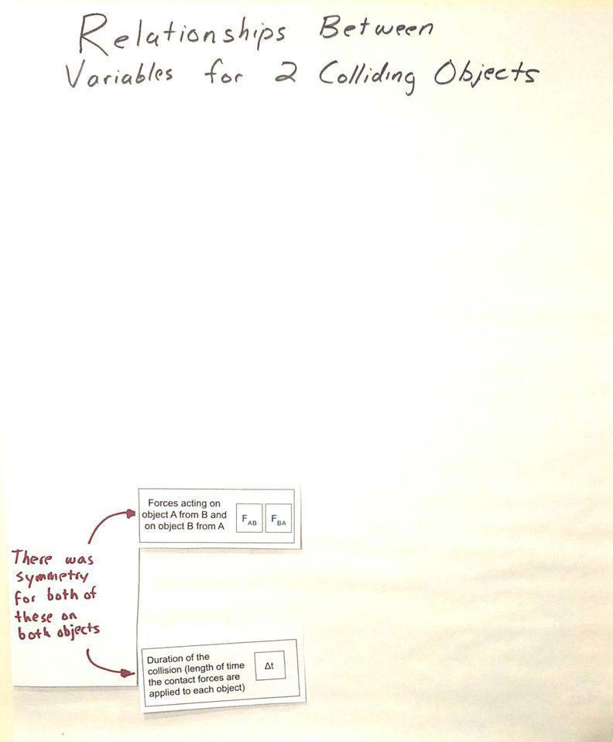  Explain that the subscript indicates first which object is applying the force, and then which object the force is being applied to. Say, We saw some interesting symmetry in these two forces as well as symmetry related to when those forces are applied. Tape this card to the left side of the poster as shown.  Introduce the Δt card. Say, let’s identify a variable to represent the length of time over which the forces are applied as well. Hold up the card (page 2 of Variable Half Sheets). Read the definition on it.  Say, So in this case delta t represents the difference between the time at which the collision starts and when it ends, which is the duration of the collision. start and the end of the collision, represents a change in or difference in t, or time. Tape this card to the left side of the poster as shown.  Add a large post-it note or half sheet of paper as shown to indicate there was symmetry in these variables on both objects.  Record the following near the front of the classroom:  - Δ is a delta symbol. It stands for a change in something or difference in a quantity.  Share patterns in speeds that we noticed as a class. Show slide I.  Suggested prompt Sample student response  What patterns did you notice in these graphs? What do these graphs tell us? In collision A and B, the yellow-green cart came to a stop in the collision, and the blue cart started moving from the collision (from initially being motionless). In collisions C the yellow-green cart slowed down and the blue cart sped up. The time over which the green cart started slowed down is the same time over which the blue cart sped up.  Foreground the difference in signs on the speeds for collision C. Present slide J. Ask students why, for Collision C, the final speed of the blue green is negative after the collision as well as what that tells us about the direction it is moving. Students should say it indicates that it is moving in the opposite direction as the other cart or that it is moving to the left, rather than to the right.  Build off students’ ideas to introduce velocity to capture direction and speed. Say, As you suggested the differences in sign indicates the differences in the direction the cart is moving. Negative values indicate movement to the left and positive values indicate movement to the right. Scientists use the term velocity when they think about the speed of an object as a vector.  Velocity :  - It is the directional speed of a object  - It is a vector quantity; it possesses magnitude (size) and direction.  - Opposite directions are assigned opposite signs.  Replace speed with velocity on the graphs. Have students cross out the labels on the y-axis on all the speed graphs of the carts on Collisions A-C Graphs and replace the word “speed” with “velocity” to more accurately reflect what is being plotted on those graphs.  Present slide K. Record the following near the front of the classroom, and give students a moment to add new entries to their personal glossaries, for speed, velocity, and force.  ADDITIONAL GUIDANCE The graphs in Collisions A-C Graphs intentionally have the y-axis labeled as speed. This was so that students can “just in time” cross out and replace the word “speed” with “velocity” to more accurately reflect what is being plotted on those graphs, after they have analyzed the graphs, which motivated needing a way to make sense of what the negative y-values represent on those graphs. | ✱ ATTENDING TO EQUITY  Support for Emergent Multilingual Learners: Take a moment to help students connect to the everyday meaning of the word magnitude, which is a long word for a very universal idea. This is particularly important for students who are learning English while also learning the vocabulary of science. Ask students where else they have heard the world magnitude used before. Students are likely to say both of these are related to their work in OpenSciEd Unit P.2: How forces in Earth’s interior determine what will happen to its surface? (Earth’s Interior Unit).  - We used the word magnitude to refer to the strength of forces before.  - We used it to also refer to the relative strength of an earthquake.  The word magma may sound similar, but it is not related. If the example of earthquake magnitude comes up, emphasize that this is another example of where magnitude is used to compare the relative size of something. Students may also have connections to other words with the same prefix that also refer to size, such as magnus, or to words in other languages, for example: magnitud in Spanish.  ✱ SUPPORTING STUDENTS IN DEVELOPING AND USING PATTERNS  While the force graphs provide evidence that the contact time was at least ~0.1 seconds long, the nonlinear trend in the forces as they approach a y-value of 0, makes it hard to know when the force is actually 0, vs. when it is really small. Some students may notice this and make connections to similar trends in radioactive decay of elements that they explored in the prior unit, Earth’s Interior Unit.  Other students may notice that the graphs for velocity shift from a linear pattern to non-linear pattern and back to a linear pattern, and that the non-linear pattern stretches over the time period that the forces were applied. These students may argue that the non-linear pattern for the speed changes is potential evidence for when the collision is occurring as well. While the shift from linear changes in velocity to non-linear changes in velocity is evidence of changing forces in the system, this relationship is beyond what we expect students to notice at this point in the unit. There is no need to dwell on this noticing if it comes up now, beyond validating that this is another interesting way of using the patterns in the data to support a claim about a potential cause and effect relationship.

6 · COMPLETE AN EXIT TICKET | 3 min
MATERIALS: Collisions A-C Graphs, science notebook

Administer an Exit Ticket. Display slide L. Ask students to take a minute to look at their graphs again and determine which collision produced the largest changes in velocity for each cart and how much the velocity of both the carts changed in those collisions. Point out that the symbol shown in the first prompt uses a delta (Δ), which again signifies a change in or difference in a quantity, so in this prompt Δ(V), is shorthand for a difference in v, or a change in velocity.

Prompt students to record a response to these questions on the bottom of Collisions A-C Graphs and either collect this as an exit ticket or have students turn in a copy of these responses on a separate sheet of paper as well.

ASSESSMENT OPPORTUNITY | What to look/listen for in the moment: Students correctly analyze the data from the sensors to identify collision C as having the largest magnitude changes in velocity and that it is a change of (or a little less than) 0.8 m/s (SEP: 5.2; CCC 1.1)  What to do: If some students struggle with determining the difference between a negative and positive value, ask students to consider how far the y-values are from the x-axis (a y-value of zero), and what this tells them about the total difference between the two y-values. This decomposition of the representation to think about distance between a negative and positive value on a number line is a review of concepts students developed as part of Math CCMS in 6th grade.  Building Toward 4.A.2 Analyze data collected from speed and force sensors and use multiple mathematical representations (bivariate graphs, grids, algebraic equations) to identify and describe patterns in the relationship between the between different variables (force, mass, velocity changes of two objects in a collision. (SEP: 5.2; CCC 1.1, 1.4; DCI: PS2.A.2)

ADDITIONAL GUIDANCE | Remove all the variable half sheets from the Relationships between variables for 2 colliding objects poster if you have additional sections, so you may reuse them in an interactive discussion again with your other classes. After finishing this piece with your last section, leave all of them posted so that you can refer to them in the second period of this lesson and in future lessons.

End of day 1
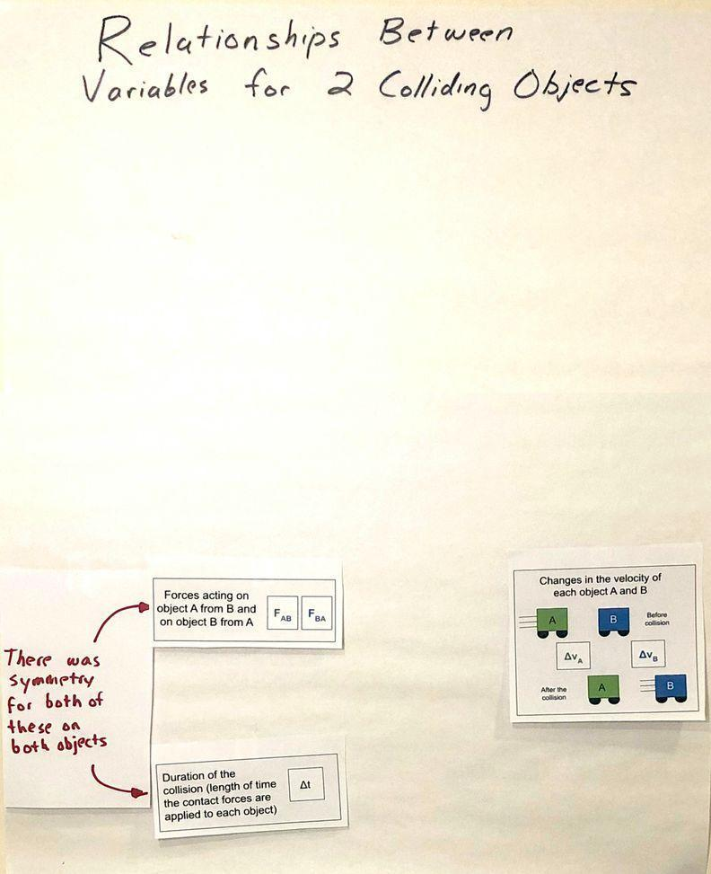  7 · SHARE EXIT TICKET RESPONSES | 2 min
MATERIALS: Collisions A-C Graphs
Share responses from the Exit Ticket. Display slide M. Distribute Collisions A-C Graphs, which you collected last class. Ask students to look back at the responses they recorded on the bottom of the page to prepare to share their answers to the questions on the slide. After doing so, have students share out.

Suggested prompt | Sample student response
Which collision produced the largest changes in velocity for each cart? | Collision C. The last collision
How much did the velocity of each cart change in that collision? | The yellow/green cart decreased by about 0.8 meters per second and the blue cart increased by about 0.8 meters per second.

8 · RECORD ADDITIONAL RELATIONSHIPS AND VARIABLES | 7 min
MATERIALS: Relationships between variables for 2 colliding objects poster, Variable Half Sheets, tape, marker, half sheets of paper
Add velocity change cards to the poster. Say, Since we’ve started calculating and comparing the changes in the velocities of the two objects as another way to analyze the outcomes of the collision, let’s add these variables to our poster too.

Hold up page 3 of Variable Half Sheets .Add the velocity change cards to the poster. Point out the delta sign again represents a change in the quantity v, which represents velocity.

Establish some initial relationships between the variables on the poster. Ask students to consider how the variables on the left side of the poster appear to be related to the variables on the right side of the poster. Suggest that they look back at the three collisions and rank order them from where the velocity changes were the largest to the smallest and then compare the magnitude of the forces across the duration of the collision. Display slide N, if needed, to prompt this. Give students 1 minute to do this. Then discuss what patterns they noticed.

Suggested prompt | Sample student response
What patterns did you notice? | The collision with the smallest changes in velocity (B) is also the one with the weakest peak magnitude forces.  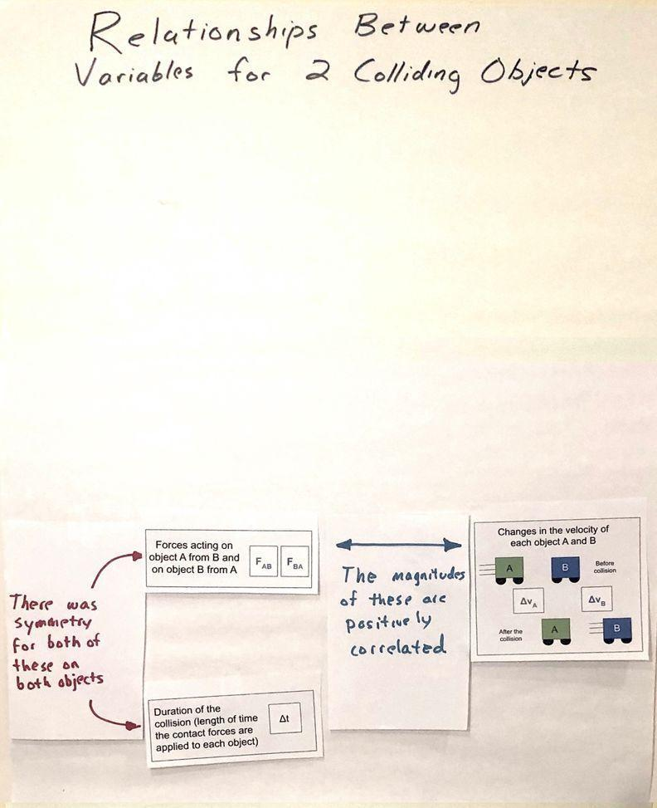  The rankings are similar.
Suggest that we make note of this relationship we noticed between the magnitude of velocity changes and the magnitude of the forces.

Add a large post-it note or half sheet of paper as shown to indicate these variables are positively associated with each other. You will replace this paper later, so tape it to the poster for now.

Discuss reasons for symmetry in forces and velocity changes on both carts. Display slide O. Read the top of the slide, to summarize the aspects of symmetry that were previously noted, and make sure everyone agrees with these statements. Then discuss the question on the slide.
Suggested prompt | Sample student response
What is happening during every collision that is causing this symmetry in outcomes? | The carts are the same size and have the same amount of matter, so they should experience the same forces.  Both carts have the same type of material and have the same mass, which is why they experience the same magnitude of force on them.
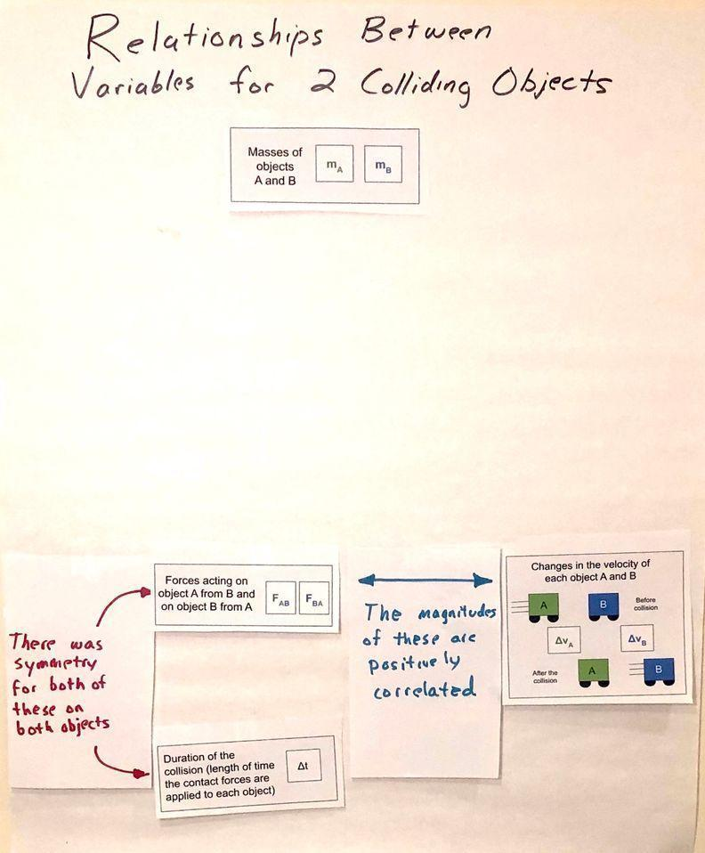
Consider further connections to the masses of the carts. Say, if I were to hold the green cart in one hand and the blue cart in another hand, I would feel the same amount of force downward on each hand. Ask students why this would be. Look for students to suggest things like:
- They have the same mass
- Gravity pulls on them the same amount
- They weigh the same

Mention that we make note that the relationship we are suggesting is related to the masses of both carts are the same.

Add the mass card, from page 1 of Variable Half Sheets to the poster.

9 · PREDICT ADDITIONAL COLLISION CONDITIONS | 6 min
MATERIALS: Relationships between variables for 2 colliding objects poster, Variable Half Sheets, tape, markers, half sheets of paper.

Make Predictions for different mass carts. Ask something like, But what do we predict would happen if we changed the mass of the carts in the system? What, if any, effect would that have on any or all of these other variables on our poster? Let’s individually think about this.

Display slide P. Read through the slide. Give students three minutes to record their predictions in their notebook.

Share predictions for both collision sets as a class. Discuss these for two to three minutes and accept all responses.

Use the differences in predictions to emphasize that we have some competing ideas of how forces and changes in the mass and changes in velocity are related to each other in a collision. Suggest that we will need to resolve this in order to make progress on some of the questions on our driving question board.

In the unlikely event that there is no controversy in predictions, frame the next step as us needing to get some data to help support (or confirm) our thinking, so we can build evidence based arguments and design solutions related to what we wanted to figure out on our Driving Question Board.

Refer to the representation of showing some uncertainty in the relationship students predicted. Add two half sheets of paper to the poster with double headed arrows on them in different colors, and suggest that we include the question “How are these related?” on each.

10 · ANALYZE AND INTERPRET DATA | 10 min
MATERIALS: Collisions D-F Graphs, science notebook, https://www.youtube.com/watch?v=DXFVadiFb_c&list=PLSLDxqPb5NQmc9aOPrh0SjG_BRiZsVdWA&index=3, computer
Analyze videos of collision scenarios. Say, We have videos and the related set of graphs from the sensors on the carts from the 3 collisions we just made predictions about for us to analyze. Cue students to take out Collisions A-C Graphs as a reference document. Display slide Q. Review the directions on the slide. Share the video link https://www.youtube.com/watch?v=DXFVadiFb_c&list=PLSLDxqPb5NQmc9aOPrh0SjG_BRiZsVdWA&index=3 with students to watch with a partner as you distribute a copy of Collisions D-F Graphs to each student.

Give students up to 8 minutes to analyze the data and work with a partner to annotate their handouts to make note of how changes in mass affected the outcomes of the collision.

11 · ARGUE FROM EVIDENCE | 7 min
MATERIALS: Collisions D-F Graphs, science notebook, calculator, Relationships between variables for 2 colliding objects poster, Variable Half Sheets, tape, markers, half sheets of paper.

Argue from evidence. Present slide R. Discuss the question on the slide:
- How does mass affect the forces on each object in a collision?
- How does mass affect the change in velocity of each object in a collision?

Make it clear to students that we are arguing from evidence, and that your role in the discussion is to press them for evidence from the graphs of the collisions.

KEY IDEAS | Purpose: The purpose of this discussion is to press for students to identify evidence from the graphs for each of the patterns they report out, so that the class comes to agreement on the following.  Listen for these key ideas related to forces:  - The forces on each cart are equal in magnitude and opposite in direction in every collision, regardless of mass differences.  - The magnitude of the maximum force in the collision increases as the total mass in the system increases (compared to Condition A.)  Listen for these key ideas related to changes in velocity.    - When masses are equal in collision D, velocity changes are very near equal in magnitude (but opposite in direction), just like in collisions A, B, and C.  - When the masses were not equal, the smaller mass cart always experienced a larger magnitude of velocity change than the larger mass cart.  - The magnitude of this change was approximately twice as big for a smaller cart compared to the larger cart.

ASSESSMENT OPPORTUNITY | What to look/listen for in the moment: Students comparing the magnitude of the forces acting on both carts in different collision scenarios and changes in velocity in order to identify patterns related to mass. (SEP: 5.2; CCC 1.1, 1.4; DCI: PS2.A.2)  What to do: If students struggle with seeing relative differences in velocity changes for collisions E and F, encourage them to use two fingers to show the gap between the initial and final velocities to get a qualitative sense of how the changes in velocity of a cart compared to another to help foreground the relative differences magnitude of velocity change (one is about twice the other).  Building Toward 4.A.3 Analyze data collected from speed and force sensors and use multiple mathematical representations (bivariate graphs, ratios, geometric models, algebraic equations) to identify and describe patterns in the relationship between the between different variables (force, mass, velocity changes of two objects in a collision. (SEP: 5.2; CCC 1.1, 1.4; DCI: PS2.A.2)
Make a public record of our findings. Suggest that we add our two categories of discoveries to our poster. Say, One finding I heard you noticing was related to collision A, that increases in mass in the system resulted in increases in the magnitude of the forces. Add this summary on a half-sheet paper with an arrow pointing from the masses to the forces and swap it onto the poster over the spot on the left that previously said “How are these related?”

Then summarize the finding related to velocity changes by saying, I also heard you saying that when masses are unequal in a collision the smaller mass changes velocity more than the bigger mass. Add this summary on a half-sheet paper, with an arrow pointing from the masses to the changes in velocity and swap it onto the poster over the spot on the right that says “How are these related?”

12 · USE MATHEMATICAL THINKING | 7 min
MATERIALS: Collisions D-F Graphs, science notebook, calculator, Relationships between variables for 2 colliding objects poster, Variable Half Sheets, tape, markers, half sheets of paper.
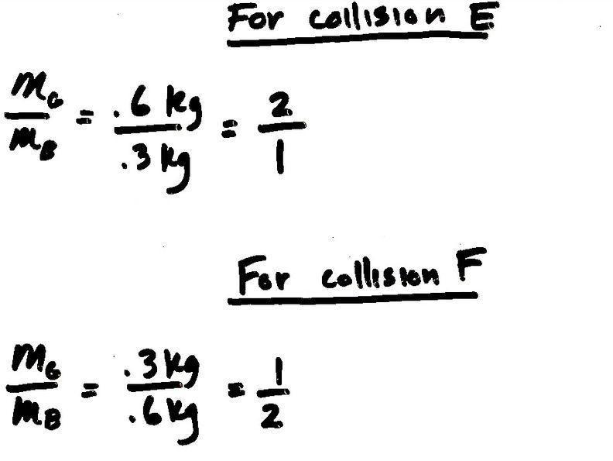
Foreground a relationship between mass differences and velocity differences. Present slide S, which has the change in velocity results from collisions E and F.

Say, In these collisions, the masses of the carts are not equal anymore. The ratio of our masses is no longer 1 to 1. What is the ratio of the masses here again?

Calculate and record this ratio at the front of the room as shown for collision E and F.

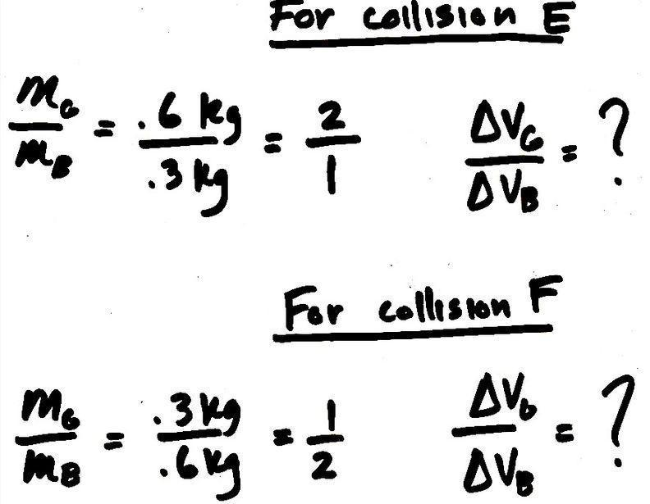
Ask students how this compares to the ratios of the velocity changes for the two carts. Write this symbolically on the board.

If students already noticed that the change in velocity was twice as large as the larger cart compared to the smaller one, remind them of this noticing. Suggest that we try to calculate the amount of velocity change for each cart, using the initial and final velocities of both.

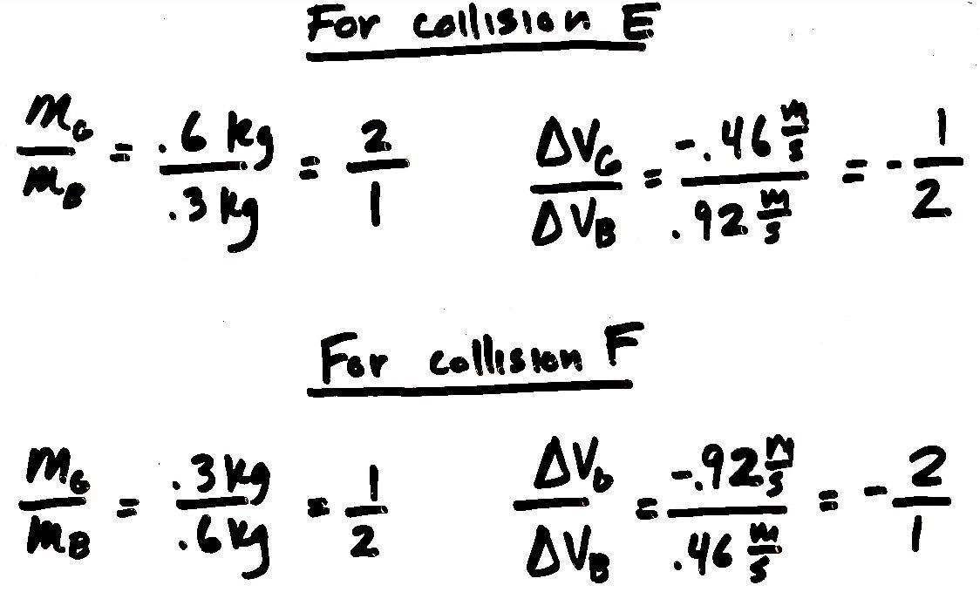
Determine the exact values for initial and final velocities. Use slide T to provide the data students need to determine the exact values for initial and final velocities. Have half of the room determine the change in velocity for each cart for collision E and the other half determine it for collison F. Ask students to quickly do the math on their whiteboards to see if the changes in velocity really are double.

Students should find that when the mass of one object in a collision is double that of the other object, the velocity change of that object is halved (and the velocity change of the smaller object is also doubled). Make sure to point out that this ratio has a negative sign. Record this ratio at the front of the room as shown. Ask them about which cart had a decrease in velocity in collision. Students should say the green cart in both collision E and F. Add a negative sign in front of the value of the numerator in collision to indicate this, and in front of the denominator of collision F to represent. Then reduce these to the equivalent fractions.

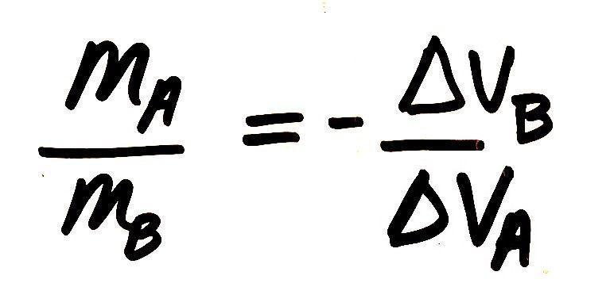
Describe the relationship we discovered between these ratios symbolically. Write the mass ratio again symbolically as shown below. Write the negative reciprocal of the change in velocity ratio on the other side of the equal side, as shown, asking students how this represents what we saw in the data. Students should say the fraction for the ratio of the velocity changes is flipped and opposite sign compared to the fraction for the ratio of the masses.

Ask students what we call it when we flip a fraction like this. Students may remember that in math we call this a reciprocal fraction and with an opposite sign in front of it, we refer to it as a “negative reciprocal”. Write “negative reciprocal” at the front of the room in front of the fraction on the right side of the equation.

SUPPORTING STUDENTS IN MAKING CONNECTIONS IN MATH | This reference to negative reciprocals, draws on students prior experiences in CCMS in middle school. One of these is related to identifying and describing the slopes of perpendicular lines in a coordinate plane; where their slopes of such lines are negative reciprocals of each other.
Make predictions in a Turn and Talk. Present slide U. Say, If we think this represents what happens when the mass of one object in a collision is doubled, what about other mass ratios? What do you predict would happen if the mass of one cart was five times the mass of the other cart and they collided? Give students a minute to discuss this with their partner. Then share out ideas as a whole class. Students should suggest that the ratio might hold true for other numbers, and that the velocity change of an object in the system will be five times that of the other object. Make sure to press students to identify which object will have the larger velocity change (the smaller mass object).

13 · NAVIGATE | 6 min
MATERIALS: None
Make connections to a real world collision scenario. Present slide V. Point to the equation on the slide, that we also have recorded at the front of the room. Ask, What does this equation mean in real life? Let’s see whether we think it has any application to a more extreme mass ratio situation. Push students to make connections to real life by grounding their understanding in a scenario, like the big truck and the shopping cart. Say, A big truck is approximately 20,000 kg and a shopping cart is approximately 20 kg. So the truck has 1000 times the mass of a shopping cart. If the truck is coasting along at a constant velocity and hits a stationary shopping cart, does that mean that the shopping cart will really undergo a change in velocity that is 1000 times larger in magnitude than that of the truck?  Accept all ideas here. Some students may argue that it should because it matches the patterns we have seen so far. Some students may not be convinced, since it seems hard to believe. If there is disagreement here, highlight it, saying something like It sounds like we are going to need more data in order to resolve this. If there is consensus, say, It sounds like we think this relationship is going to hold even for these extreme scenarios.  Motivate the need to test even more scenarios. Ask, And what about situations where we aren’t changing just mass ratios. Our empirical evidence is pretty limited right now. All we have different mass related data for is for collision E and F, both of which had one object that was moving initially and one that was stationary initially. What if both the objects are moving? What if they don’t bounce off each other, and instead they stick together, which is considered an “inelastic” collision? Ask, Can you think of a collision where you’ve seen two things collide and they stuck together instead of bouncing off each other? Accept all ideas.  Take a quick poll. Display slide W. Accept all responses, again emphasizing either areas of controversy or the need for additional data to support a prediction we are largely in agreement on.  Introduce the idea of using a simulation next time to explore this question further. Say, I do have a sim that we can use next time that will allow us to explore whether this relationship holds for any of these other collision conditions we’ve been considering and/or determine what limitations it might have.  SUPPORTING STUDENTS IN MAKING CONNECTIONS IN MATH These are two core CCMS related ideas that are targeted in this this lesson: Number and Quantity - CCSS.MATH.CONTENT.HS.N-VM.1 Vector and Matrix Quantities: Represent and model with vector quantities. Recognize vector quantities as having both magnitude and direction. Algebra - CCSS.MATH.CONTENT.HS.A-SSE.1b Seeing Structure in Expressions: Interpret the structure of expressions | ✱ ATTENDING TO EQUITY  Supporting Emergent Multilingual Students: There are many prefixes in English that mean “not” or “the opposite of” and this can be confusing for students, particularly those who are multilingual. Point out that the word inelastic is a word we have encountered before (elastic) with a prefix that means “not.” Ask students if they can think of any other words that begin with “in” and mean “not” whatever comes after, such as incompatible, infinite, or inalienable.

